Hi Rich
So sorry it took this long to send the email I promised earlier, I had some issues come up and was seriously detained.

We love discussing how Tombstone Jack can meet your needs.
Here is some additional information about our company and products to help you.

About Tombstone Jack
Tombstone Jack is dedicated to providing innovative and reliable lifting solutions that simplify and enhance
the efficiency of headstone and monument repairs. Our flagship product, the Tombstone Jack (TJ 4200), is
engineered to safely lift and level small tablets, heavy tombstones, and monuments up to 12,000 lbs., making those
restoration and maintenance tasks more manageable. We designed the product in 2011 and have customers across North America. We ship daily by UPS.

TJ 4200™
Price: $4,239.00
Shipping: $469.00

There are two different ways to use the system:
- Clamps
- Lift Feet
Watch TJ 4200 Demonstration Here

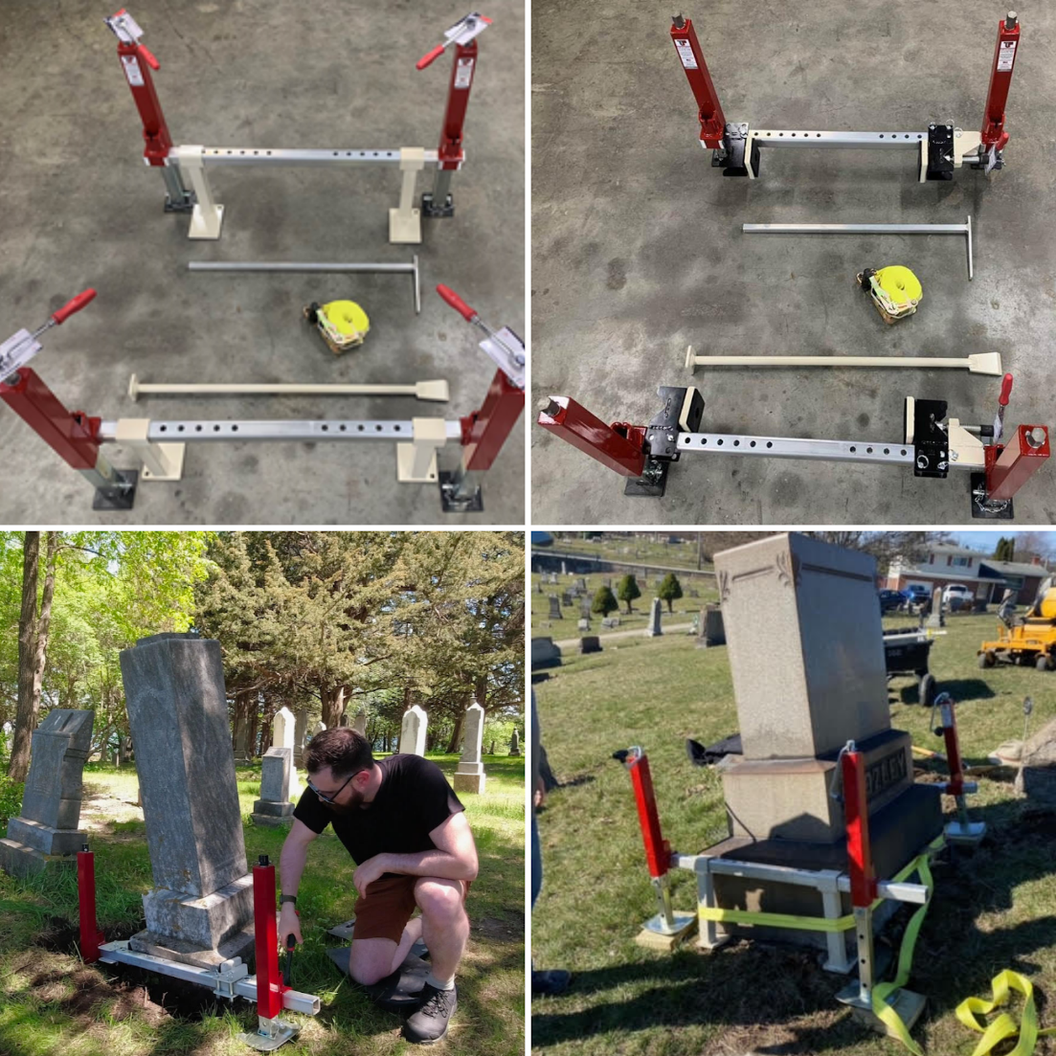
*The unit comes standard with hand crank handles. Ratchets and top nuts are sold separately.

The “Elite” Organizing Wagon Kit
Price: $469.00 USD On Sale now $250.00
While supplies last…

This kit is used to move your equipment around safely and quickly, and there is a place designed for everything!

Purchase the wagon from Amazon or your local Home Depot, Lowes, or other hardware store for approximately
$265.00 USD. The organizing kit attaches to the wagon with 6 - 3/8” bolts, washers, and nuts.
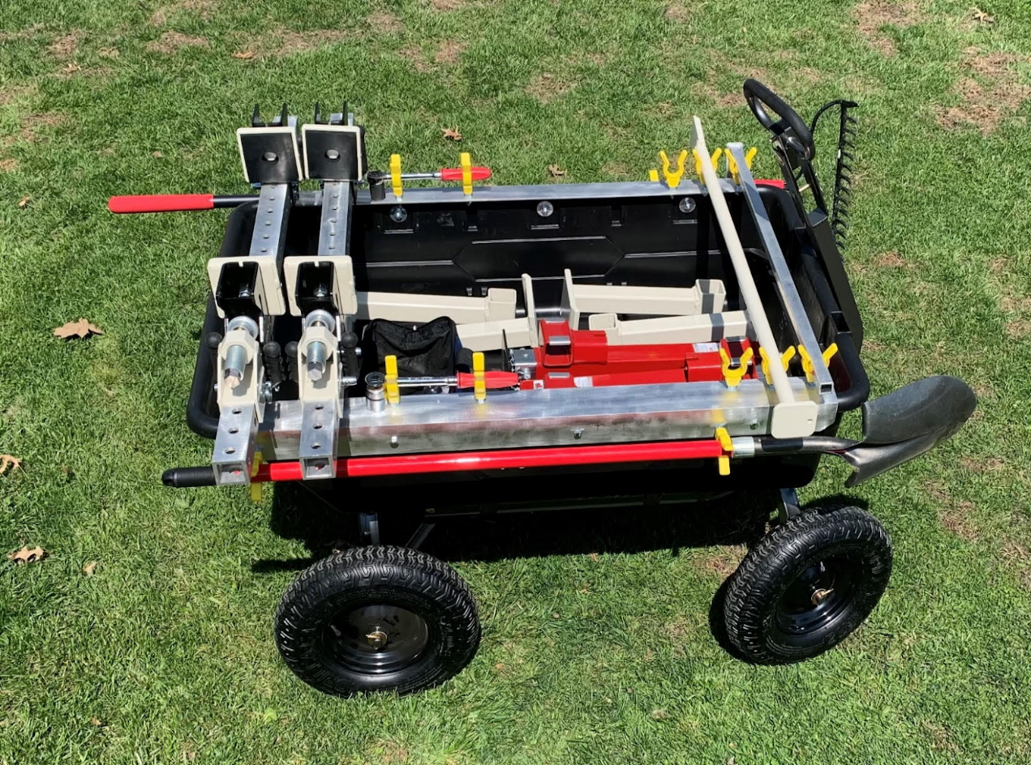
If you have any questions or need additional information, please don't hesitate to reach out.
Thank you once again for considering Tombstone Jack. We look forward to the opportunity to work with you and support your monument restoration needs.

We have inventory and can ship once we have received payment.

We sincerely look forward to talking with you again.

Best regards,
Michael



